User Story

#101

As a member of the Relationship Managers, I want to be able to capture customer’s profile details and identification through interactive voice response so that the process of selling packages and providing a service would be quicker.

Est: 6 Imp: High

#301

As a member of the Relationship Managers, I want to be able to call automatically from my target list through a predictive dialler call centre so that they can offer products and solve customer problems faster.

Est: 5 Imp: High

#103

As a member of the Relationship Managers, I want the customer to be able to purchase holiday packages so that the company can increase sales.

Est: 4 Imp: High

#104

As a customer, I want to be able to choose and view my holiday package with live chat (modern call centre software features) instead of receiving phone calls during reservation so that the process would be convenient and easier.

Est: 3 Imp: Medium

#102

As a customer, I want to have a 24 hours office operator for cancelling and changing my holiday package so that I don’t need to wait for a long time.

Est: 3 Imp: Medium

#201

As a member of the Relationship Managers, I want the customer to receive the latest package and marketing notification via SMS so that the notifications can be easily obtained.

Est: 2 Imp: Low

User Story Map

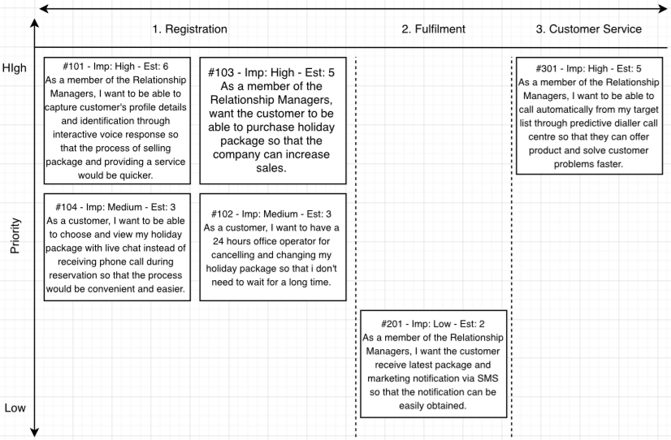

Use Cases

|  |  |
| --- | --- |
| Use Case ID | #UC201: Latest Package and Marketing Notifications |
| User Story | As a member of the Relationship Managers, I want the customer receive latest package and marketing notifications via SMS so that the notification can be easily obtained |
| Goal | SMS helps the business to deliver a message to customers about their latest package and marketing notifications |
| Priority | Low |
| Actors | Primary – Relationship Managers and SMS system  Secondary – Customer |
| Pre-conditions | The customer has an authentic phone number  The customer has a mobile device that can be able to receive SMS |
| Post-conditions | The SMS system sends latest package and marketing notifications to the customer |
| Trigger | There are latest package and marketing details available to send to customer |
| Main Flow | 1. The Relationship Managers has updated the latest package and marketing notifications into an SMS service that makes it easy for customers to read 2. The Relationship Managers send notifications to the SMS system. 3. The SMS system helps to notify all customers in the system 4. The customer can receive notifications via the SMS application which is usually called messages apps 5. The use case end |
| Exceptions | Exception (1) Step 2 – When the SMS system is down |
| Includes/Extends/Inherits |  |
| Supporting Information | N/A |
| Non-functional Requirements | Implementation: SMS must be able to get customers in at least one minute to notify them  Security: Secure customer’s phone number and other profile details |